ECE 49595

EE DESIGN PROJECTS

Fall 2016

FINAL DEMO: SYSTEM MANUAL

Transparent USB Audio Headphone Amplifier

By

Team 2

Section 4 Team Number 2

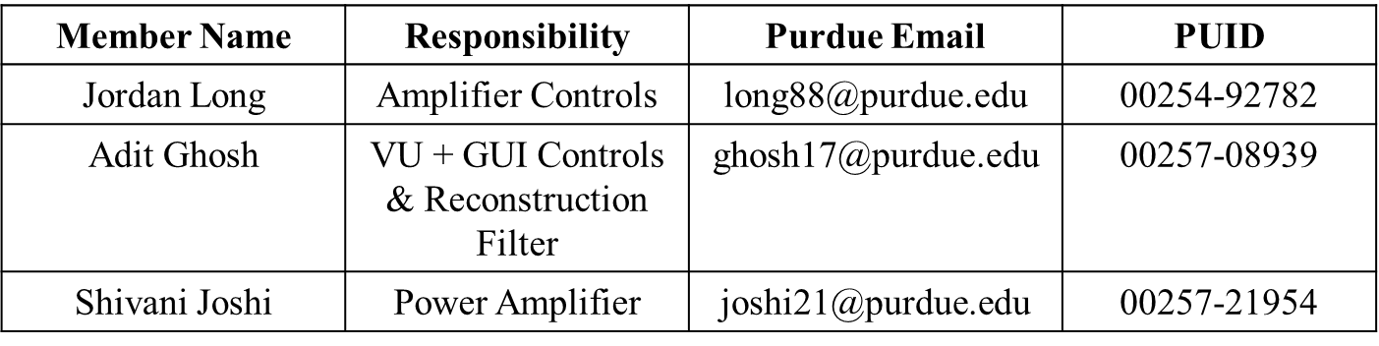

# TABLE OF CONTENTS

1. SYSTEM DESIGN BLOCK DIAGRAM………………...............................................  3
2. INSTRUCTIONS…………………………………………………………………..… 4-5
   1. SETUP INSTRUCTIONS………………………………………………………… 4
   2. OPERATING INSTUCTIONS……………………………………………………. 5

4. SUBSYSTEM CHAPTER .......................................................................................... 6-36

4.1 RECONSTRUCTION FILTER ...........................................................................  6-10

4.2 VU + GUI CONTROLS .....................................................................................  11-18

4.3 AMPLIFIER CONTROLS .................................................................................  19-28

4.4 POWER AMPLIFIER ........................................................................................  29-36

APPENDIX A ...........................................................................................................................  37

A1 Specification Sheets of Major Devices …....................................................  38-42

1. SYSTEM DESIGN BLOCK DIAGRAM

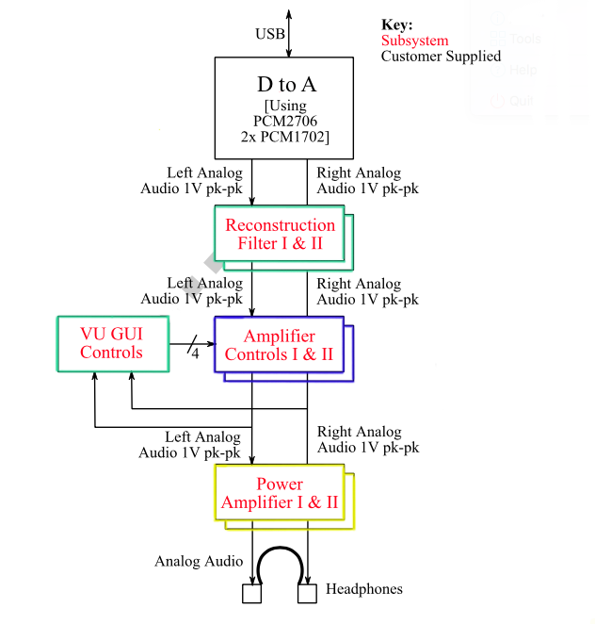

Figure 1. System Block Diagram

2. INSTRUCTIONS

2.1. Setup

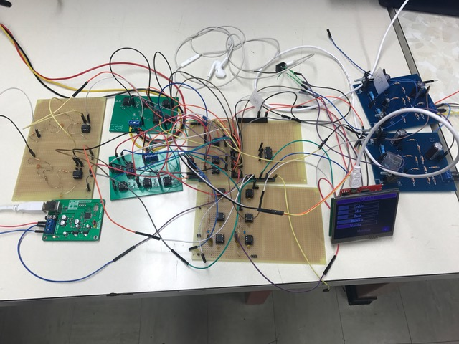

**Headphones for Output**

**Power Amplifier**

**Amplifier Controls**

**Reconstruction Filter**

**Balance Control**

**Rectifier**

**D-to-A**

**GUI**

Figure 2. Final Product

To set up the Transparent USB Audio Headphone Amplifier, all four subsystems must be obtained; D-to-A, GUI-VU and reconstruction filter, amplifier controls, and power amplifier. Arrange PCB and perf-board as shown in Figure 2.

       The first step to combining the system is to correctly connect the D-to-A system to the reconstruction filter. Following the reconstruction filter, connect the output to the left and right channels of the Amplifier Controls by wiring the output to the input pins of the Amplifier Controls PCB’s.

       Next, connect the VU-GUI to the amplifier controls to ensure proper adjustments of tone controls and volume. The digital potentiometers in the amplifier controls subsystem utilize three digital signals from the microcontroller: CLK, SDI, and CS. To wire the system correctly, connect the CLK signal from the TIVA to all CLK inputs on the Amplifier Controls. Repeat this action for the SDI signals. In order to successfully control each potentiometer individually, ensure that each CS signal is wired correctly to it's respective potentiometer. The pin labeled JP6 on each PCB is the input for the balance potentiometer and the pin labeled JP7 is the total output for each Amplifier Controls PCB. This output is connected to two voltage followers which then feed the outputs for both the VU meter and the Power Amplifier.

       The final step is to connect the amplifier controls to the power amplifier. Using male to female connection wires, connect the left output pin on the amplifier control to the left input pin of the power amplifier. Be sure to connect the ground pin of the power amplifier to the common ground being used by all other subsystems. From here, connect the left audio jack pin to the left output pin of the power amplifier. Repeat these steps with the right signal and pins on the right power amplifier.

 2.1. Operation

Once the Transparent USB Audio Headphone Amplifier is set up, a USB cord from a PC to D-to-A subsystem can be connected to receive sound from the computer and headphones, of user’s choice, can be attached to the audio jack.

        The D-to-A system will pass a signal from the PC to the reconstruction filter.

        The signal is then passed through a reconstruction filter. This smooths out high frequency sampling produced by the DAC. The filter has a cut off frequency of 42 kHz as the DAC provided to us over-samples two times.

        The filter is connected to the amplifier controls subsystem. The signal tones and volume can be adjusted by the user through the GUI interface.

The GUI adjusts Volume, Balance, Treble, Mid and Bass by sending out SPI signals to digital potentiometers. The customer actively alters the SPI signals by using the sliders on the GUI touch screen to change the audio output to his/her liking. Moving the slider to the right will induce greater filter boost and/or an increase in volume, depending on the attribute being changed. Moving a slider to the left will result in greater cut or a reduction in volume of the audio output, the exact opposite affect of what happens when moving the slider to the right. The VU meter analyzes the input signals and displays a scaled version of the wave on the touchscreen

Finally, the amplifier controls send the signal to the power amplifier. Here, the signal is amplified in voltage by the preamplifier, then amplified in current by the power amplifier. In total, this amplifies the power, providing the signal just enough to drive a varity of headphones, ranging from 16Ω to 600Ω

3. SUBSYSTEM CHAPTER

3.1 Reconstruction Filter

The reconstruction filter is used to produce a smooth analogue signal from the DAC’s digital input. It removes the high sampling frequency of the D to A to prevent damage to sensitive parts of the circuit. This could include preventing mechanical damage of the speaker. Thus, a very high quality filter will be required. The Reconstruction filter will incorporate a 3rd order Butterworth filter. Filters approach ideal filter behavior as the order approaches infinity. At the same time filters tend to get expensive and difficult to implement as the order increases. We are assuming that the DAC will oversample data 4 times. Butterworth filters have no pass or stop band ripple and it has a flat frequency response. Other filters that were considered were Chebyshev and Bessel.

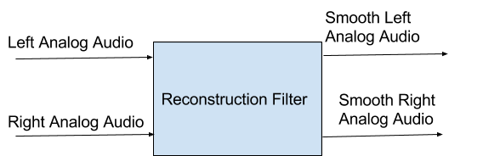

Figure 3. Block Diagram for Reconstruction Filter

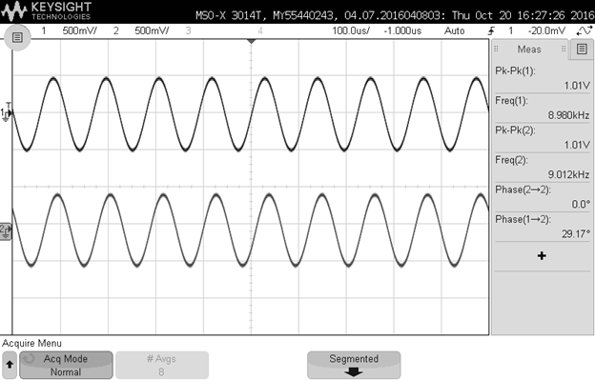

Output

Input

Figure 4. Reconstruction filter Voltage pk-pk

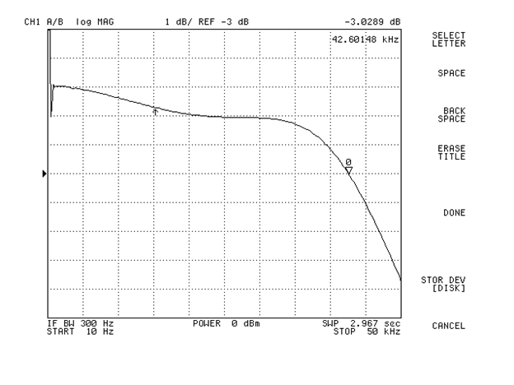

Figure 5. Magnitude and Phase Response of the Reconstruction Filter

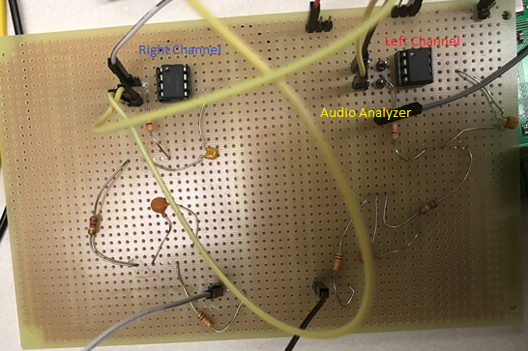

Figure 6. Circuit for Reconstruction Filter

Manufacturing Test & Instructions:

1. Tested a 1V pk-pk sine wave using the oscilloscope and made sure the reconstruction filter produces a 1 V peak-to-peak signal.

2. The reconstruction filter was tested using the audio analyzer to verify that it’s 3dB is within the specifications. Obtained a sampling frequency of 44.2 kHz.

Expected Results:

1. Obtain a 1V pk-pk output for a 1 V pk-pk input signal

2. Obtain a cut off frequency of 42.10 kHz.

Parts cost:

None

Equipment List:

1. OpAmp

2. Wires

Power requirement

1. +/-5V

Connection

1. Use the output ports of the Reconstruction Filter as shown in Figure 6 and attach it to a audio analyzer.

3.2 VU + GUI Controls

The GUI accepts user input to control audio signals output via a touchscreen. This consists of a TIVA microcontroller & a compatible touchscreen. The touchscreen provides a slider interface for the user to adjust audio controls. The microcontroller interfaces to 5 digital potentiometers which are in the Amplifier controls. It does this via SPI. The VU meter removes negative values in the input waveform. It uses a full wave rectifier that converts the whole of the input waveform to one of constant polarity, in this case positive.

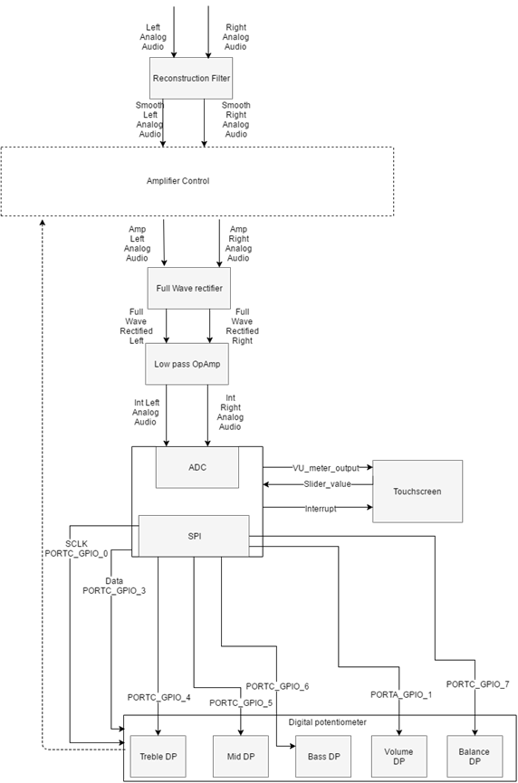

Figure 7. VU + GUI Controls Block Diagram

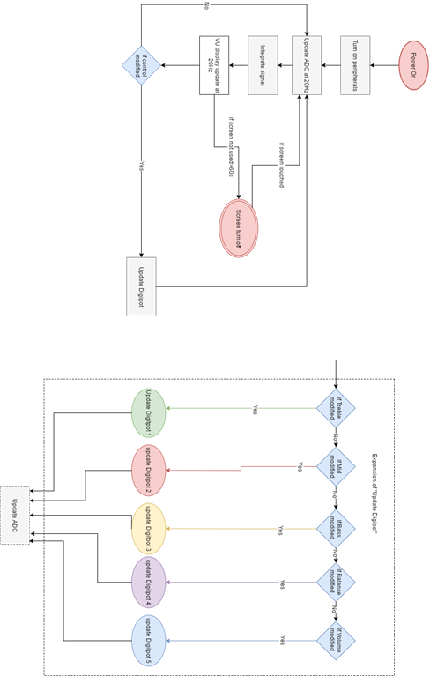

Figure 8. VU + GUI Controls Activity Diagram

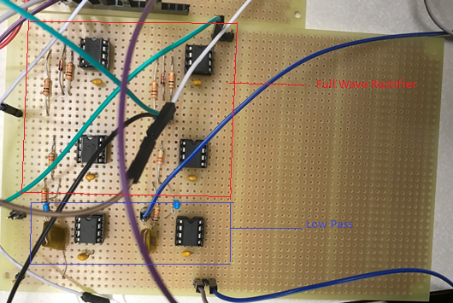

Figure 9. Circuit for Rectifier

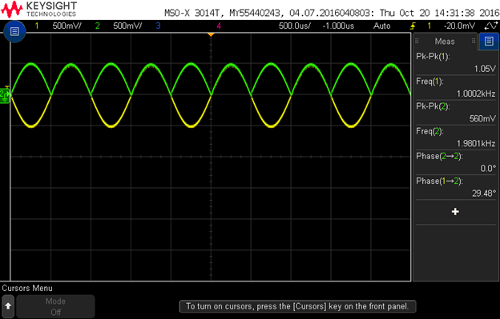

Input

Output

Figure 10. Full Wave Rectifier Output

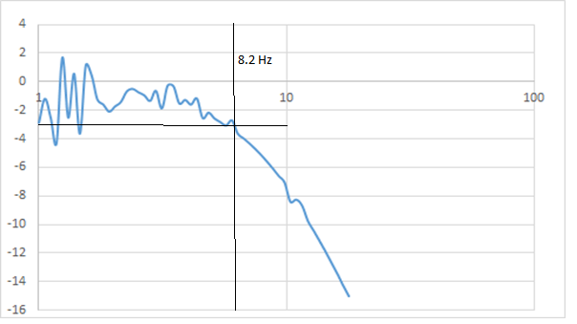

Figure 11. Analyzer Output for Rectifier Circuit 3dB

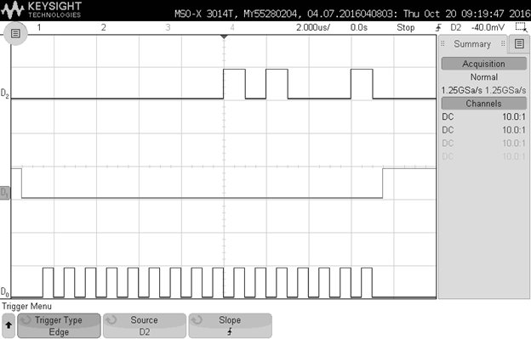Figure 12. SPI output for Slider change

(D2 = Address, D1 = Chip select, D0 = Clock)

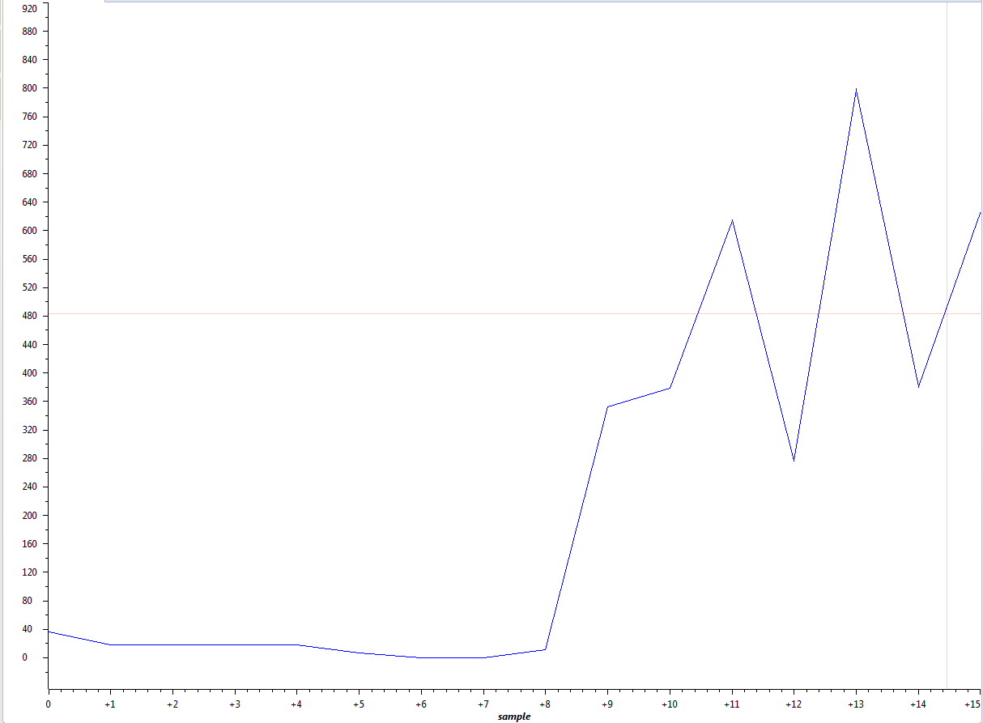

Figure 13. ADC Response to a 1V pk-pk Sine Wave

Manufacturing Test & Instructions

1. SPI

The Microcontroller's SPI outputs were checked by hooking it up to a oscilloscope. This ensured that the pins are outputting correct data.

2. ADC

Tested the VU meter with function generator sine wave inputs to ensure that the VU update is consistent with the wave frequency.

3. Touchscreen display

Ensure that the sliders change without hanging

4. Overall Subsystem

A change in the sliders on the touch screen produces a change in the volume/balance/treble/mid/bass of the output sound as observed on the speakers.

Expected Results

1. If the input signal to the ADC is low we expect the VU to display a low value and high VU  value if the input is high.

2. We expect a change in sound quality(Volume/Balance/Bass/Treble/Mid) when the corresponding digipot is changed.

Parts Cost

1. Digipods - $50

Equipment List

1. Tiva Microcontroller

2. Kentec touchscreen

3. Digipots

4. Wires

Power requirement

1. 3.3V from Power Supply

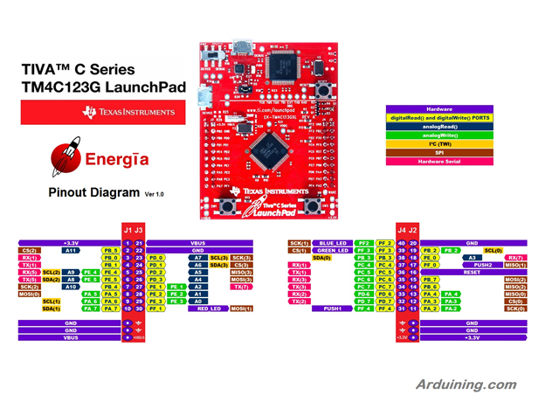

Figure 14. TIVA Pin Layout - Connection Diagram for GUI-VU

* We hook up PE1 to a sine wave generator and observe its output on the VU meter
* We hook up PD0 as clk and PD3 as address to all our digipots. We use PC4, PC5, PC6, PC7 and PE2 as chip selects for Mid, Treble, Bass, Balance & Volume respectively and observe the signals on the oscilloscope.

3.3 Amplifier Controls

The starting point at which the amplifier controls subsystem begins is called the input stage. This input stage receives both the left and right audio signals from their respective reconstruction filters. The signals are passed through unity gain, inverting operational amplifiers with 22kΩ resistors to set a large input impedance for the tone controlcircuit. The output of the op-amp also includes a capacitor to block dc. Following the input stage, the audio signal is passed through the tone control circuit. The tone control is essentially a stack of three filters: a low-pass filter, band-pass filter, and high-pass filter. First, the low-pass filter is utilized to control the bass frequencies of the signal that pass through. The minimum project requirement for the tone controls is +/- 6dB of gain. The low-pass filter used in the amplifier controls subsystem has approximately +/- 16dB of gain control that can be adjusted via a potentiometer. This low-pass filter has a 3dB cutoff at 250 Hz. Next, the band-pass filter in the tone stack works to allow a specific range of frequencies, approximately 300 Hz to 7kHZ, to pass through to manipulate their gain. The mid control filter has +/- 17dB of gain control, again adjustable by a potentiometer at a center frequency of 1kHz. Finally, the tone control stack is complete with a high-pass filter to control the treble frequencies. The treble control, just like the previous two tone control filters, uses a potentiometer to adjust the gain. The filter has a total of +/- 13dB of gain control and has a 3dB cutoff frequency at 8kHz. With the variance in the signal flow due to the gain settings of the three filters, the customer controlled signal must ultimately be summed prior to being input to the inverting op-amp. The summed signal is now passed through a second inverting operational amplifier. This second op-amp brings the previously inverted signal from the input stage back into phase. A linear phase response is required to meet the project specification which explains why two inverting op-amps have been utilized. A flat frequency response and THD < 1% are also project specifications that have been met and can be verified by viewing the output plots following this explanation.

Following the filter amplifier, the filtered audio signal is now passed through to the volume/balance controls while also going through feedback to the tone controls. The left and right signals are sent through a digital potentiometer in series with the op-amp’s output acting as a volume control.  The final output to the Power Amplifier subsystem is passed through the wiper of the volume potentiometer; however, the third pin of the potentiometer is connected in series with the balance potentiometer. This potentiometer works to connect both the left and right channels while acting as a voltage divider to allow more or less of the signal to pass through a specified channel. The volume is fully controllable from 0-100% by either using the volume slider on the GUI. The balance potentiometer works in a similar manner by shorting either the left or the right channel to ground such that the shorted signal cannot be heard on the output. The digital potentiometers that the customer controls on the GUI touchscreen receive input via SPI from the VU + GUI subsystem. The Amplifier Controls PCB includes pin headers that can receive the CLK, CS, and SDI signals from the VU + GUI subsystem which allow the customer to control the boost and cut of the tone controls. The Amplifier Controls subsystem receives input from the VU + GUI subsystem into the tone controls section for control of the bass, mid, and treble frequencies while the volume/balance controls receive input from the VU + GUI subsystem to adjust the potentiometers for the volume and balance levels. The resulting audio amplitude signal is passed to the VU meter for visual playback to the customer. The amplifier controls output is also passed to the Power Amplifier subsystem for signal amplification. All project specifications including gain control, volume, balance, frequency response, phase response, noise and THD have been met and the results can be found in thefollowing output plots.



Figure 15. Amplifier Controls Subsystem Block Diagram

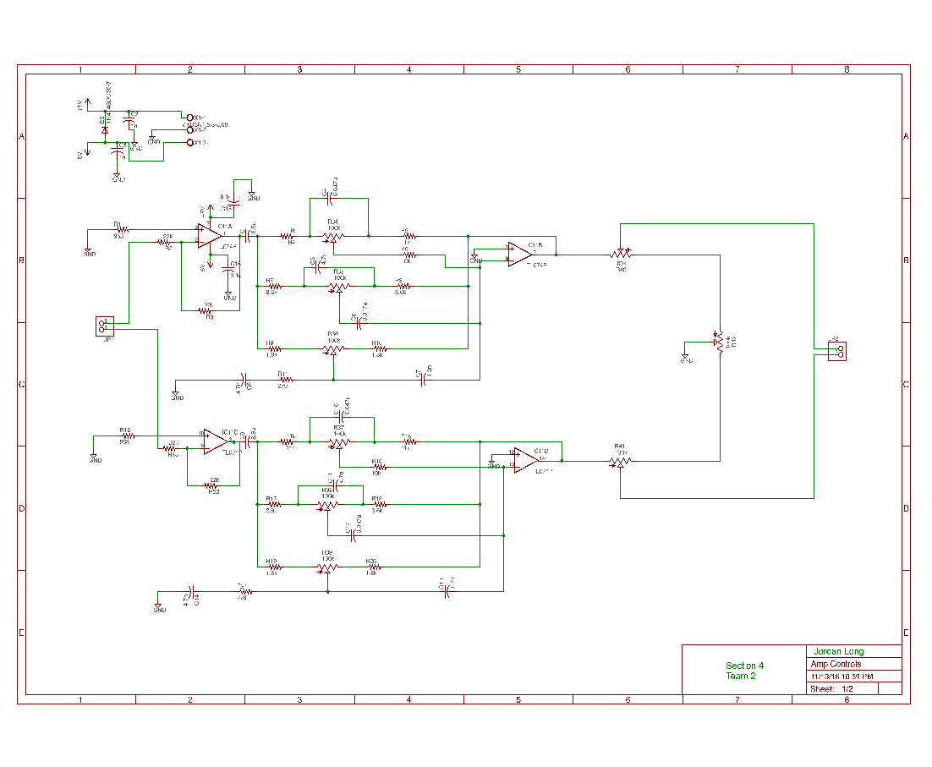

Figure 16. Amplifier Controls Schematic

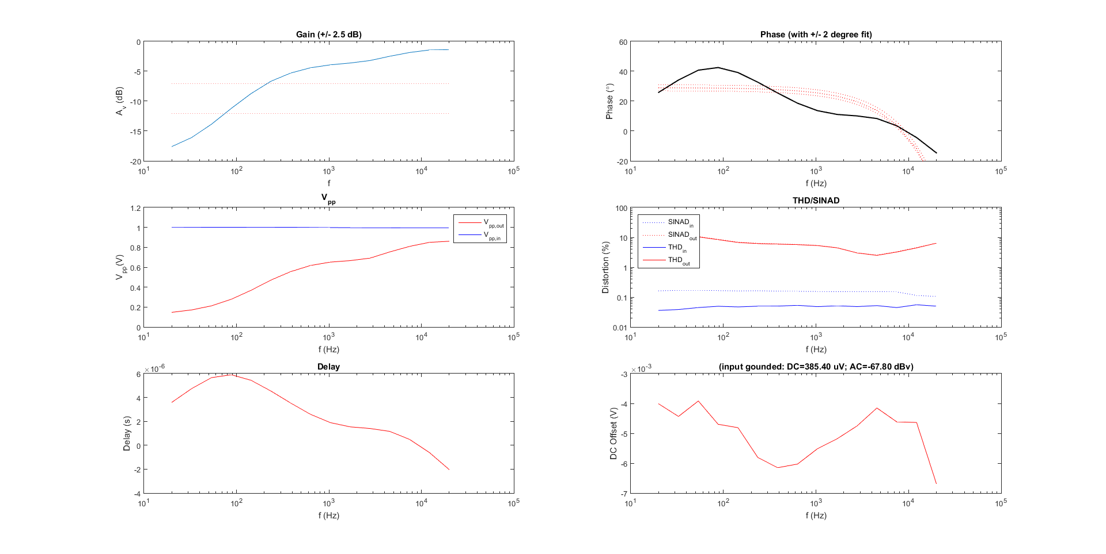

Figure 17. Base at Maximum Cut

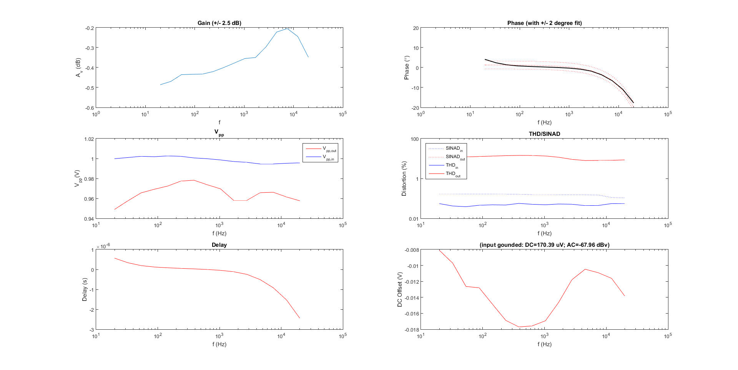

Figure 18. Flat Frequency and Phase Response

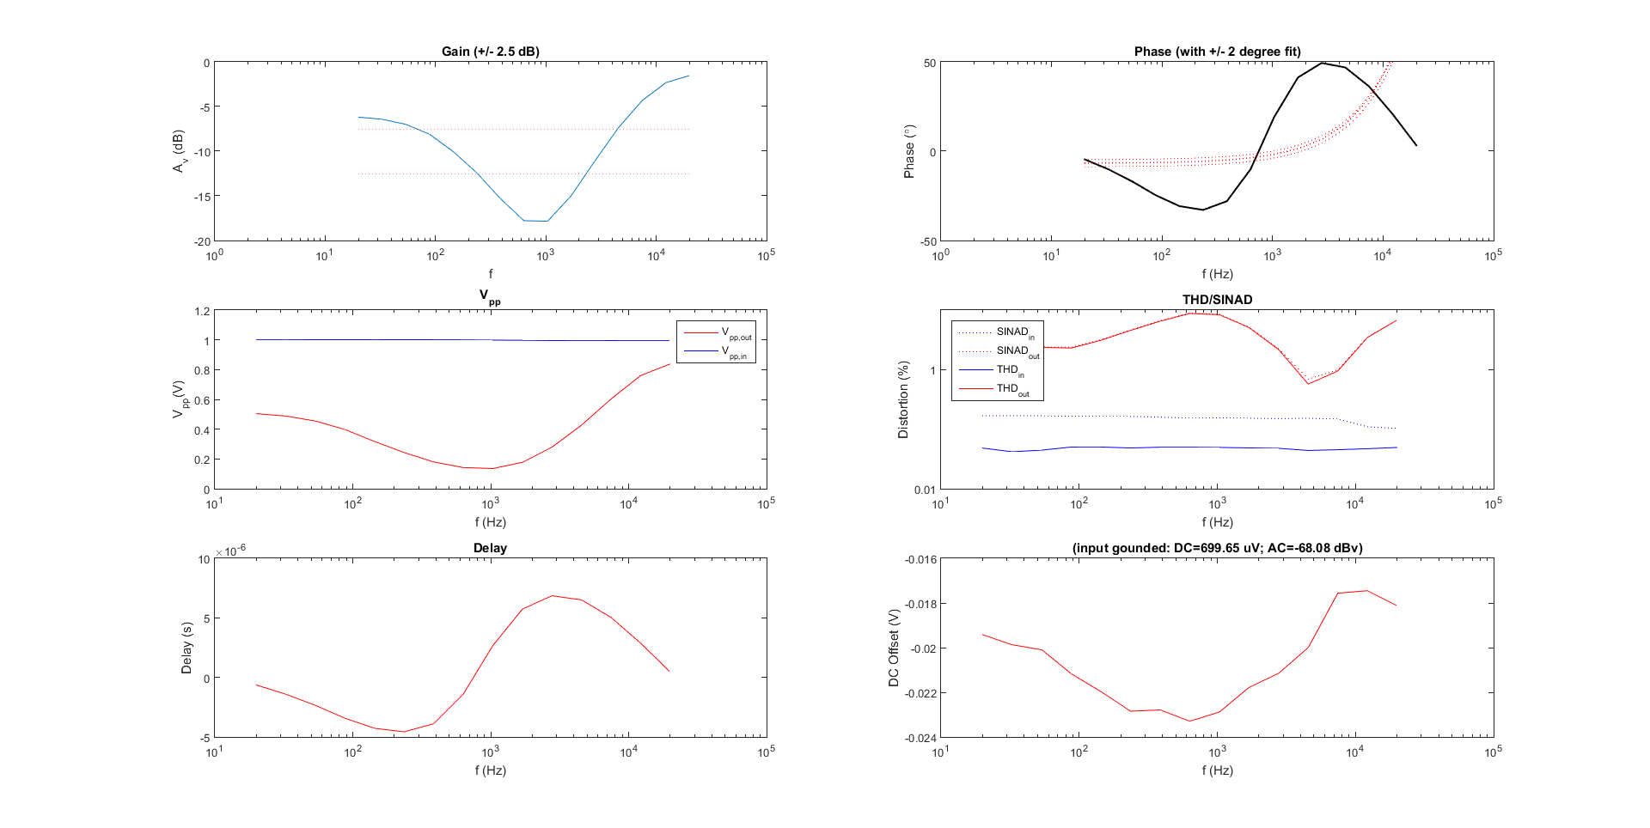

Figure 19. Mid at Maximum Cut

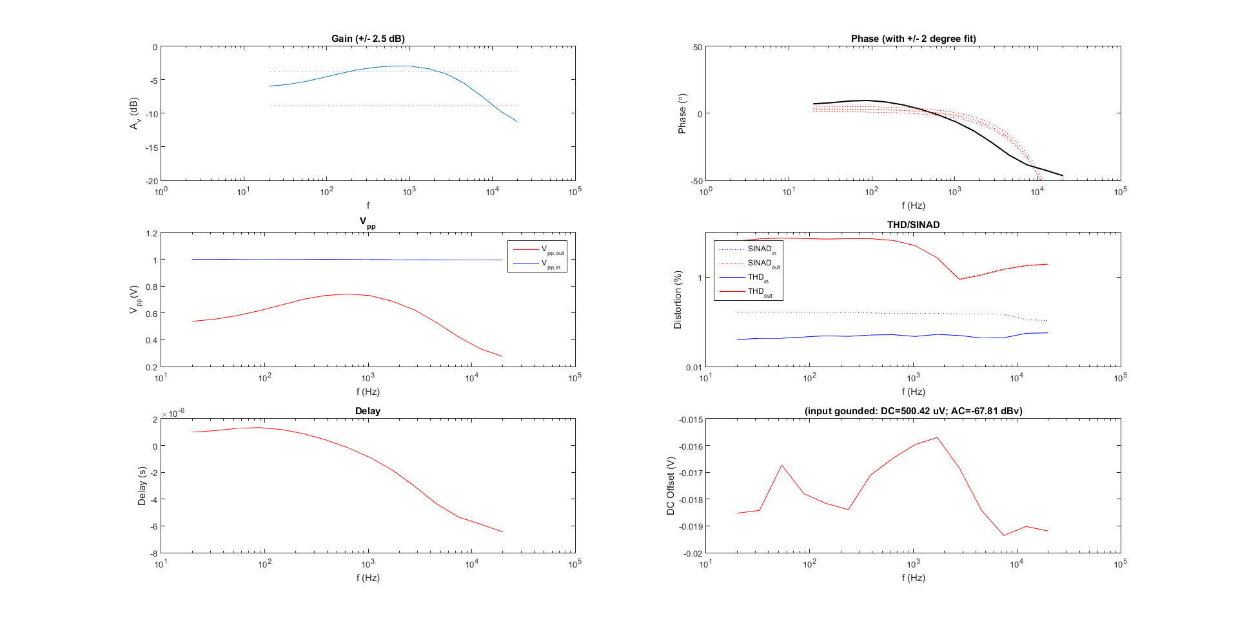

Figure 20. Treble at Maximum Cut

Manufacturing Test & Instructions:

1. Tone Controls Test

1) Connect the Amplifier Controls PCB to the Power Supply, applying +/- 5VDC to the power rails.

2) Connect the signal from the waveform generator to the input of the Amplifier Controls and ground the signal accordingly.

3) Connect channels 1and 3 of the oscilloscope to the input pin and the output pin of the Amplifier Controls PCB, respectively. Ground the scope probes accordingly.

4) Ensure the oscilloscope and the waveform generator are connected to the PC via USB

5) Open Matlab and add the folder titled osc_freq_resp_v8 to the path

6) Run the code with the subsystem at different Bass, Mid, and Treble inputs to test the system’s frequency and phase response along with its THD and noise

2. Volume/Balance Test

1) Remove the waveform generator from remote mode and change its frequency to any value between 20-20,000 Hz (1Vpp)

2) Adjust the Volume and Balance sliders on the GUI touchscreen to view the system’s response on the oscilloscope to changing the volume and balance characteristics

Expected Results:

1. Bass: +/- 13dB of gain

2. Mid: +/- 13 dB of gain

3. Treble: +/- 13 dB of gain

4. Volume: fully adjustable from 0-100%

5. Balance: fully adjustable from 0-100% in left or right channel

6. Flat frequency response with tone controls set to zero

7. Linear/flat phase response

8. THD < 1% and noise requirement met

Parts Cost:

1. Amplifier Controls PCB - $31

Equipment:

1. Amplifier Controls PCB’s

2. TI TL-074 quad input op-amps

3. Resistors

4. Capacitors

5. Wires

Power Requirements:

1. +/- 5 VDC to power both channels of the Amplifier Controls PCB (including the Balance Controls solder board)

2. Maximum of 40 mA of current to be supplied to the Amplifier Controls subsystem



Figure 21. Connection Diagram for Amplifier Controls

3.3. Power Amplifier

The final subsystem for the Transparent USB Audio Amplifier is the power amplifier. This system will take the final signal, passed from the amplifier controls, and amplifier the power enough to drive the headphones connected and used by the consumer. The power amplifier consists of two main systems; a preamplifier and power amplifier. The left and right signals from the amplifier controls will each pass through a preamplifier which will amplify the voltage of the signal. Then, these signals will pass through a power amplifier to amplify the current and will finally produce an output to one of the user designated headphones. User specifications mentioned the use of OpAmps is prohibited for the power amplifier system, therefore, a Class AB transistor amplifier design is used. This design allows for an NPN transistor to be used as a preamplifier and two transistors, one NPN and one PNP, to be used in a push-pull fashion as power amplifier. This design has a typical efficiency of 50%-60%, allowing for ideal power amplification while using a reasonable amount of power. The Class AB amplifier design also allows for high input impedance and low output impedance, which is necessary to meet the output impedance specification required by the user.

The output impedance is calculated by 1/gmTIP31 + R11, as corresponds to the TIP31C transistor and resistor R11 from Figure 23. gmTIP31 is calculated by measuring IE of TIP31C and dividing by Vt=26mV. From the breadboard design, gmTIP31=30mA therefore Rout = 5.867Ω. Although this design does not provide the means to reach the specification of an output impedance of <2Ω, an adjustment of this resistor would be able to meet spec. A larger power resistor was used to the distortion of signal when using a 1Ω resistor. This design is able to drive headphones with a load impedance of 16Ω and greater. Distortion and noise in the power amplifier subsystem is created mostly by the transistors and can be seen in the results from the Matlab script shown in Figure 25. The slew rate requirement can be adjusted by altering the time constant (resistor and capacitor) values. The DC offset is measured at the point where the feedback look insects with the output of the power amplifier. The offset is required to be less than 20mV and is set by the 7kΩ resistor. Although it takes a few seconds to stabilize, the DC offset stays under 20mV.

Together with these adjustments and calculations, the user desired specifications will all be met with a power output aimed to stay under 1W.

Figure 22. Power Amplifier Block Diagram



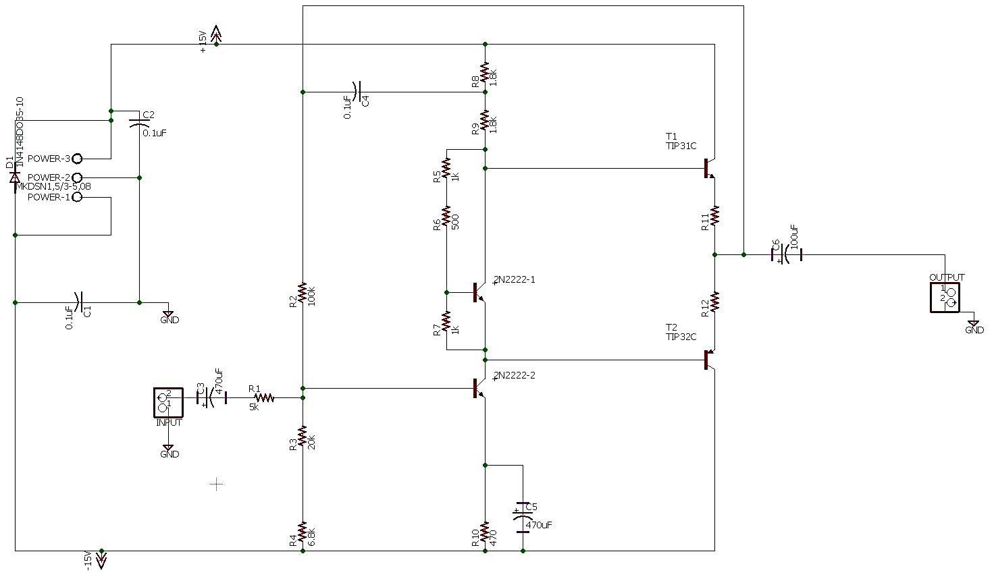

Figure 23. Power Amplifier Schematic

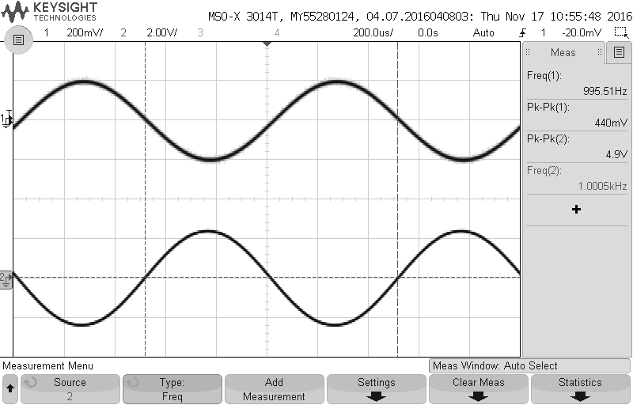 Figure 24. Signal Amplification at Minimum Resistance (16Ω)

Output

Input

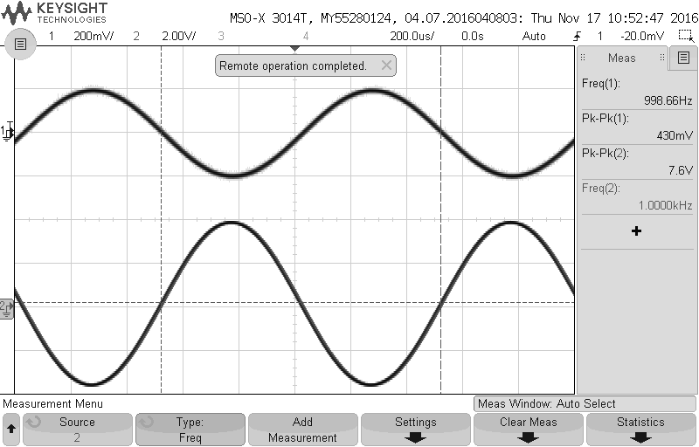

Output

Input

Figure 25. Signal Amplification at Maximum Resistance (600Ω)

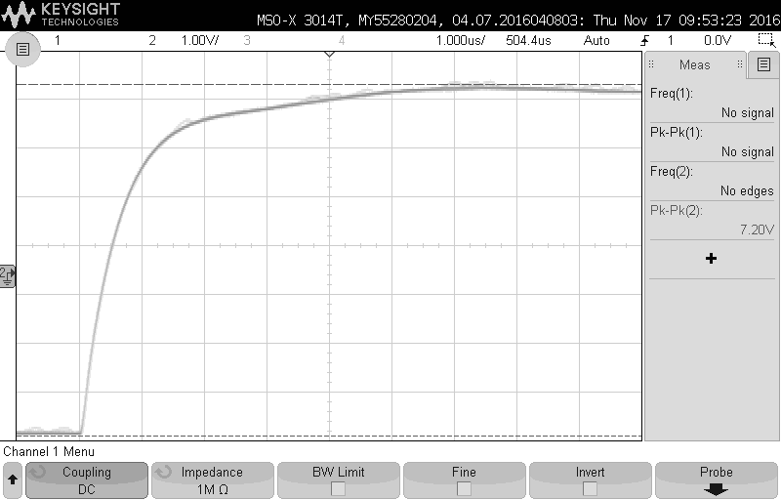

Figure 26. Slew Rate

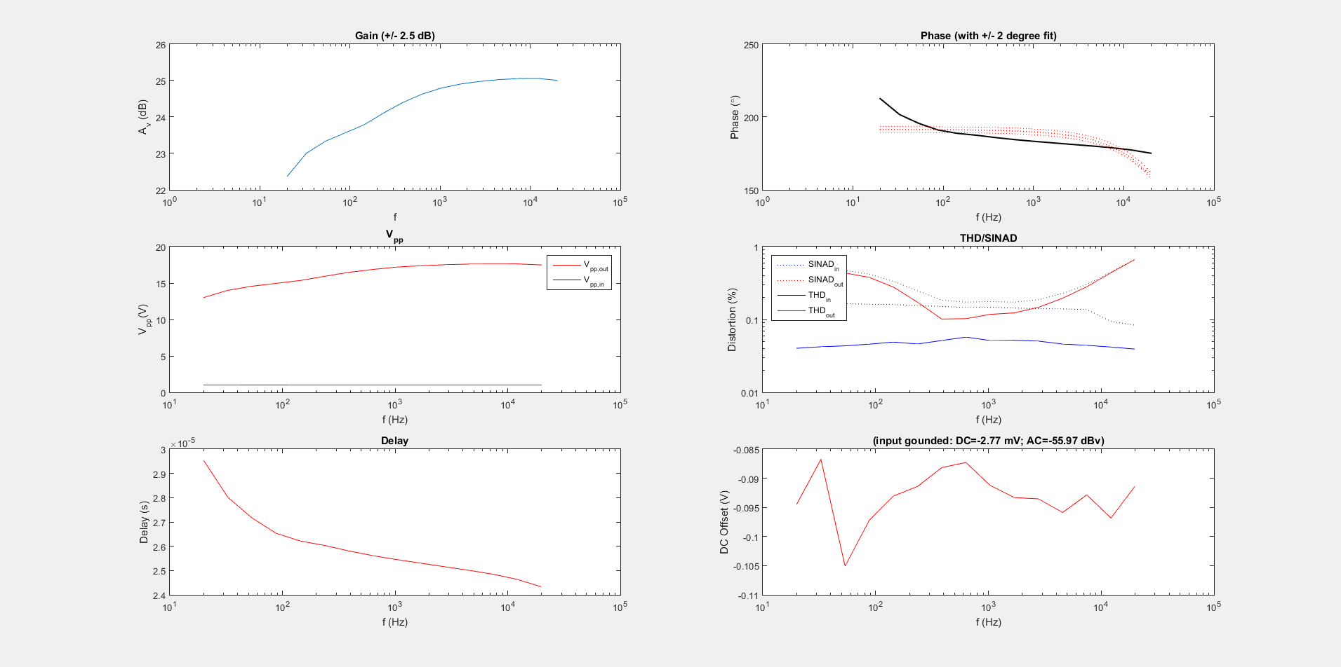

Figure 27. THD Distortion, DC Offset, and Gain

Manufacturing Test & Instructions::

1. Power amplification

1) Connect the Power Amplifier PCB to the Power Supply, applying +/- 15VDC to the power rails.

2) Connect the output signal from the function generator to the input of the Power Amplifier. Ground the function generator’s signal accordingly.

3) Connect probes 1and 2 of the oscilloscope to the input pin and the output pin of the Power Amplifier PCB, respectively. Ground the scope probes accordingly.

4) Set the function generator to any test sine wave with amplitude between 100mVpp and 1Vpp and frequency between 20Hz to 20kHz.

5) Observe the amplified signal. Amplification of any kind corresponds to amplifier power in the system.

2. Noise and THD Distortion

1) Connect the Power Amplifier PCB to the Power Supply, applying +/- 15VDC to the power rails.

2) Connect the output signal from the function generator to the input of the Power Amplifier. Ground the function generator’s signal accordingly.

3) Connect probes 1and 3 of the oscilloscope to the input pin and the output pin of the Power Amplifier PCB, respectively. Ground the scope probes accordingly.

4) Ensure the oscilloscope and the waveform generator are connected to the PC and LabView Software via USB.

5) Open Matlab and add the folder titled osc_freq_resp_v8 to the path.

6) Run the code. This will produce results for distortion and noise. Be sure the distortion is under 1% to meet user specifications.

3. DC operating point

1) Connect the Power Amplifier PCB to the Power Supply, applying +/- 15VDC to the power rails.

2) Connect the output signal from the function generator to the input of the Power Amplifier. Ground the function generator’s signal accordingly.

3) Connect the DMM to the bias point between the Push-Pull transistors and measure the DC voltage at this point.

4) This point will prove the DC offset is under 20mV.

Expected Results:

1. DC Offset of <20mV

2. Output resistance of 5.8Ω due to 5Ω power resistor

3. Distortion under 1%

4. Power amplification to drive headphones with resistances of 16Ω to 600Ω

Parts Cost:

1. Power Amplifier PCB - $42

Equipment List:

* 2 Power Amplifier PCBs (one for each left and right signal amplification)
* Audio Jack
* Wires (connect between subsystems)

Power Requirements:

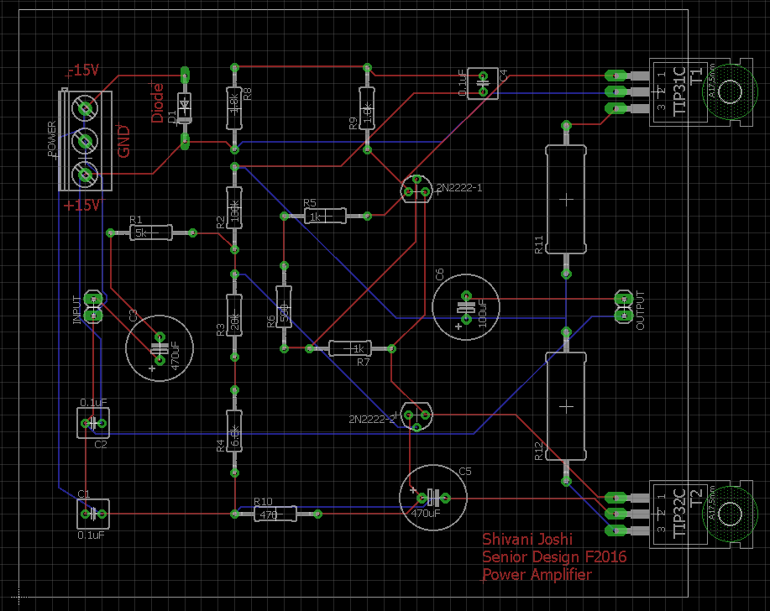1. +/- 15 VDC to power both channels

2. Under 1mW of power at output

Figure 28. Connection Diagram for Power Amplifier

* DC offset is well under 20mV (ranging from -25mV to 15mV) and can be measured at point 1.
* Output resistance is measured as 1/gm + R of the transistor and resistor show at 2.
* Noise and distortion was measured using the Matlab script, as described in the manufacturing test.
* Slew rate is shown by sending a test input square signal and measuring the rise time.

APPENDIX

1. Specification Sheets of Major Devices

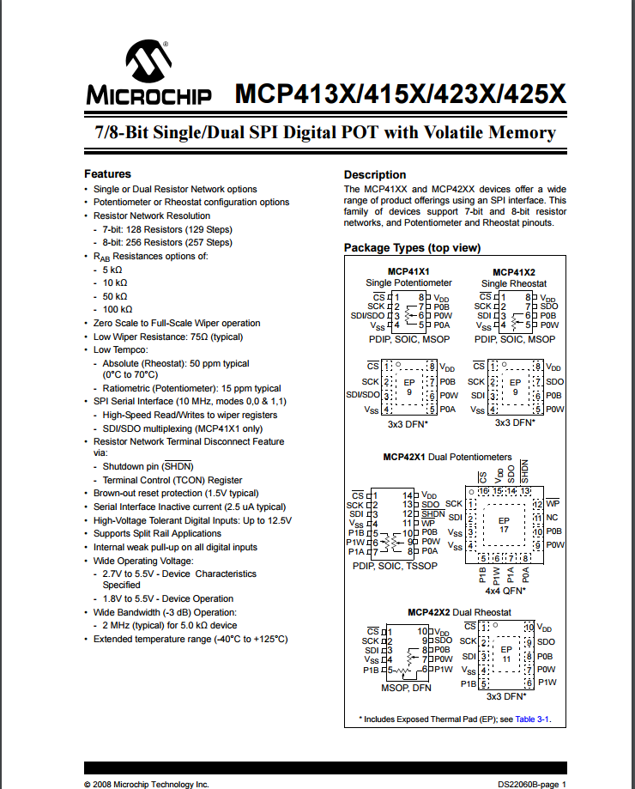

Figure 29. Digipod

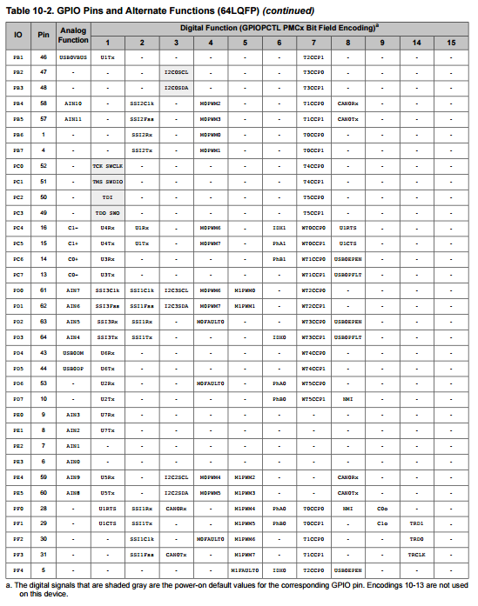

Figure 30. Microcontroller

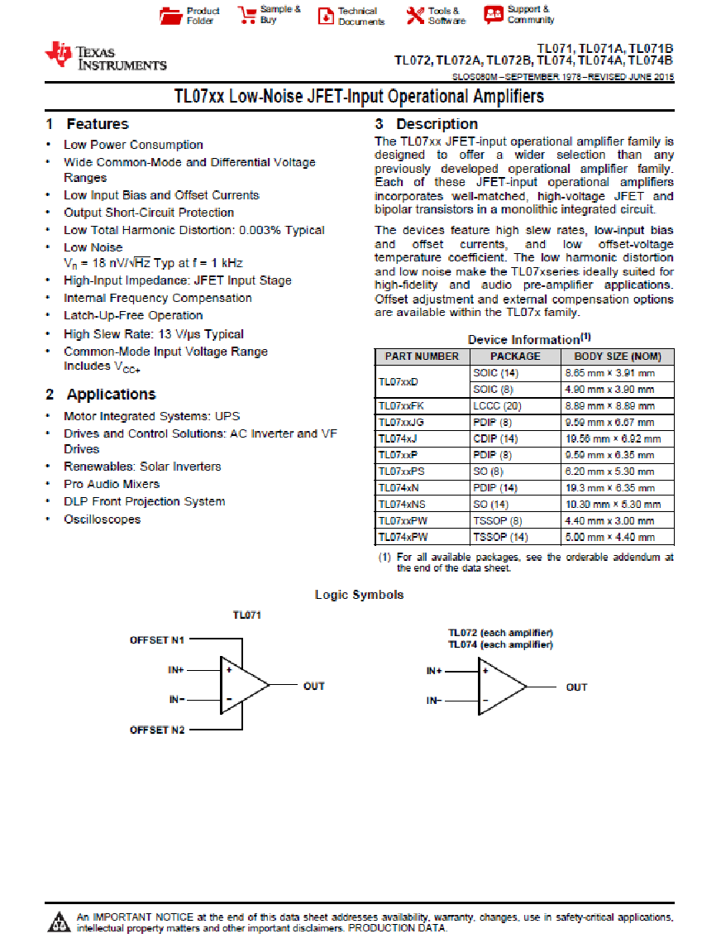

Figure 31. OpAmp

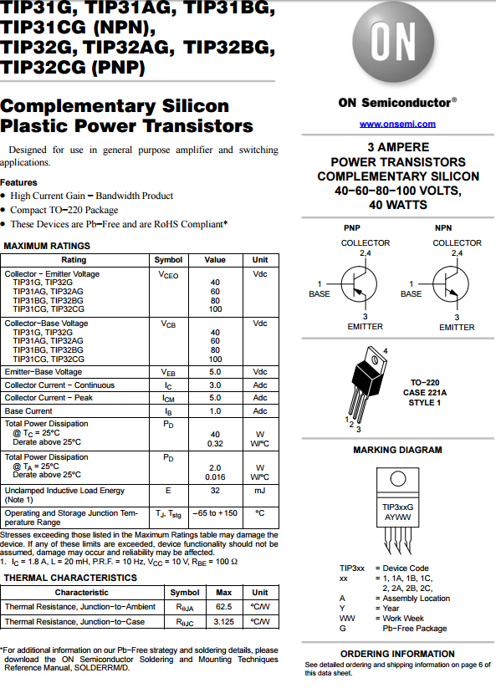

Figure 32. TIP31C Transistor

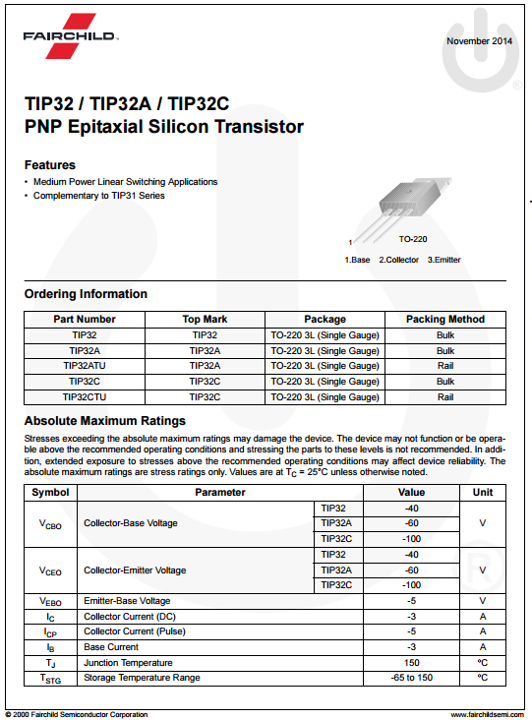

Figure 33. TIP32C Transistor

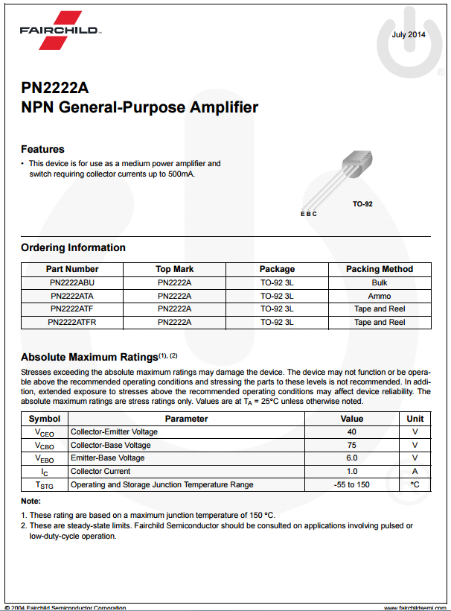

Figure 34. 2N2222 Transistor